**Appendix 1: Examples of Data augmented by reflection**

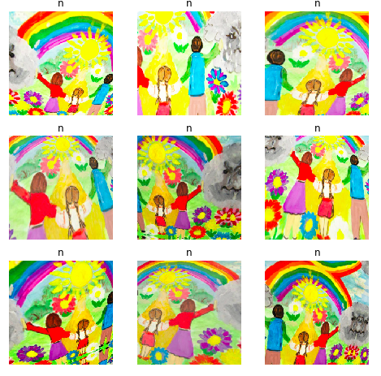

**Appendix 2: Heatmaps highlighting the yellow sun and the yellow cat**

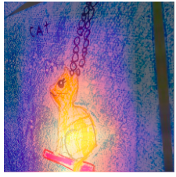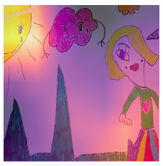

**Appendix 3: Heatmaps highlighting red color of the pumpkin and tongue**

